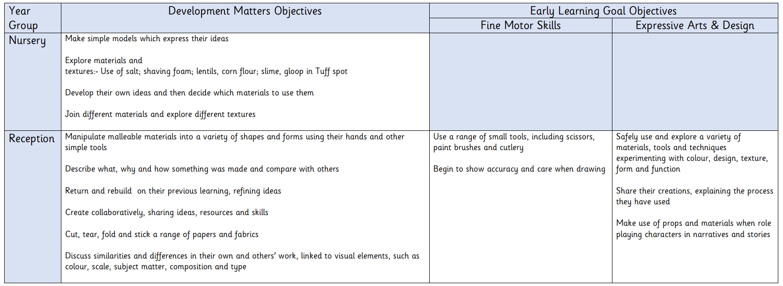
EYFS Design and Technology Objectives

